A l b u q u e r q u e A r e a I n d i a n

H e a l t h B o a r d, I n c.

AUDIOLOGY PROGRAM
CONTRACT #242-04-0010

2014 4th Quarterly Report

STAFF:

Chris Atkinson Audiology Program Manager
Leslie Hinshaw, M.S., CCC-A Audiologist
Margie Mexicano Audiology Technician
Lynell Old Lodge Audiology Program Specialist

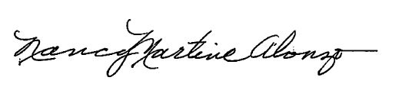

Submitted by:__________________________ Date: 01/16/15

Nancy Martine-Alonzo
Acting Executive Director, AAIHB

PROGRAM ACTIVITIES OCTOBER-DECEMBER 2014

Marge Mexicano and Donna Lasiloo conducted hearing screenings at Southern Ute Headstart on October 1, 2014.

Marge Mexicano and Donna Lasiloo conducted hearing screenings at Southern Ute Academy on October 2, 2014.

Marge Mexicano conducted hearing screenings at Dulce Headstart and Dulce Schools on October 7-8, 2014.

Marge Mexicano participated in the Dulce Child Find on October 9, 2014.

Marge Mexicano conducted hearing screenings at Ramah Headstart and Pinehill School on October 15, 2014.

Leslie Hinshaw retired as Senior Audiologist after 11 years of service with AAIHB on November 1, 2014. The Audiology Program is currently advertising for the position. Lori Workizer and Todd Powell will continue to cover all clinics until a replacement is hired.

Marge Mexicano and Donna Lasiloo conducted hearing screening rechecks at Southern Ute on November 6, 2014.

Marge Mexicano and Donna Lasiloo participated in the Ignacio Health Fair on November 7, 2014.

All staff participated in the Christmas Luncheon with the Board of Directors on December 13, 2014.

